How did Hitler consolidate power 1933-1934?

In January 1933 Hitler became chancellor of Germany and by August 1934, he had declared himself Führer - the absolute leader of Germany.

What happened during this time that allowed Hitler
to take the ultimate position of authority?

If you are asked about how Hitler consolidated his power, remember that the question is not just about describing what happened and what Hitler did. You should explain how Hitler's actions helped him to consolidate his power - it is more about the effects of what he did.
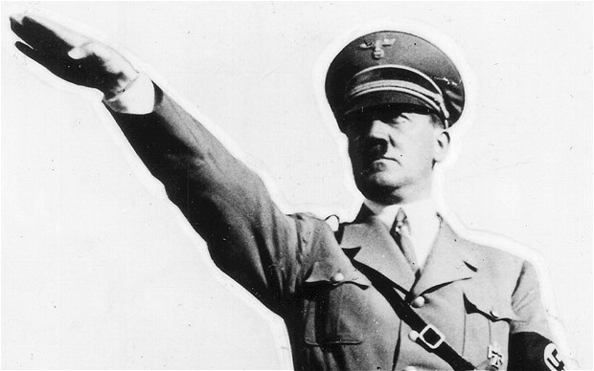
TASK 1:
In a sentence define the meaning of each of the following words:
Führer, consolidate, authority,

TASK 2:
The consumable table describes how certain events that happened between 1933 and 1934 gave Hitler the opportunity to consolidate power.

The events and their dates have been mixed up. Match the events and their dates using scissors & glue. Mark each event for its importance in terms of Hitler consolidating power – 10 being most important.

Which event(s) did you score highest? Explain why. Which events scored lowest? Explain why.

TASK 3:
How useful is Source A in understanding Hitler’s rise to power?

TASK 4:
Explain how the events during the period 1933-1934 allowed Hitler to consolidate his position of authority.

SOURCE A
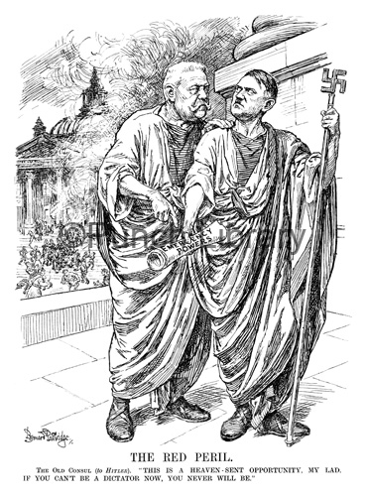

SOURCE A: A cartoon from a British magazine by Bernard Partridge, 8th March 1933.The text reads ‘The red peril – This is a heaven sent opportunity my lad. If you can’t be a dictator now you never will’

Date | Event | Importance 1-10
27 Feb 1933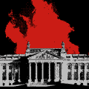 | Trade unions are abolished and their leaders arrested.
5 Mar 1933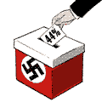 | Political parties are banned - only the Nazi party is allowed to exist.
23 Mar 1933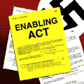 | Führer - when Hindenburg dies, Hitler declares himself jointly president, chancellor and head of the army.
26 April 1933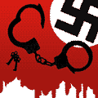 | Night of the Long Knives - some SA leaders are demanding that the Nazi party carry out its socialist agenda, and that the SA take over the army. Hitler cannot afford to annoy the businessmen or the army, so the SS murders perhaps 400 of the SA members, including its leader Röhm, along with a number of Hitler's other opponents.
2 May 1933 | Reichstag Fire - the Reichstag building is set on fire. A Dutch Communist, van der Lubbe, is caught red-handed in the burning building.
20 June 1933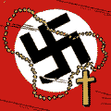 | People's Courts - Hitler sets up the Nazi people's courts where judges have to swear an oath of loyalty to the Nazis.
14 July 1933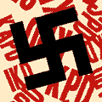 | General Election - only 44 per cent of the population vote for the Nazis, who win 288 seats in the Reichstag.
24 April 1934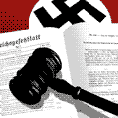 | Concordat - Hitler makes an agreement with the Pope who sees him as someone who can destroy communism. This agreement allows Hitler to take over political power in Germany as long as he leaves the Catholic Church alone.
30 June 1934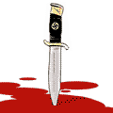 | Local government is reorganised - the country is carved up into 42 Gaus, which are run by a Gauleiter. These Gaus are separated into areas, localities and blocks of flats run by a Blockleiter. Hitler sets up the Gestapo.
19 Aug 1934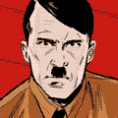 | Enabling Act - the SA [SA : Also known as Storm Troopers or Brownshirts. A military style organisation of the Nazi party formed in 1921 under Hitler. ] intimidates all the remaining non-Nazi deputies. The Reichstag votes to give Hitler the right to make his own laws.
How did Hitler consolidate power 1933-1934?

