**Senator McCarthy and HUAC-methods used**

**Hollywood Ten**

**Hiss case**

**Rosenberg case**

[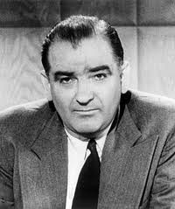](http://www.google.co.uk/imgres?imgurl=http://upload.wikimedia.org/wikipedia/commons/thumb/f/fa/Joseph_McCarthy.jpg/250px-Joseph_McCarthy.jpg&imgrefurl=http://en.wikipedia.org/wiki/Joseph_McCarthy&h=299&w=250&sz=17&tbnid=NsQwZoHIkMcWrM:&tbnh=90&tbnw=75&prev=/search?q=senator+mccarthy&tbm=isch&tbo=u&zoom=1&q=senator+mccarthy&docid=B9dmBYfu1jExDM&hl=en&sa=X&ei=0SihT4WlOqqK4gSp352vCQ&ved=0CDwQ9QEwAg&dur=608)

**Cold War in Europe**

**China and the Korean War**

**Opposition to McCarthy’s methods**

**Civil Rights in the 1950s**

**Race riots**

**Protests and campaigns**

**I have a dream……**

[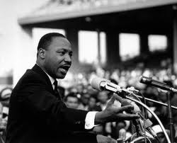](http://www.google.co.uk/imgres?q=martin+luther+king+jr&hl=en&biw=1280&bih=799&tbm=isch&tbnid=FWNrtOHOoq48tM:&imgrefurl=http://blog.timesunion.com/yourday/events-honoring-dr-martin-luther-king-jr-albany-schenectady-troy-saratoga-springs/6273/&docid=zfWeWUIfImEy0M&imgurl=http://blog.timesunion.com/yourday/files/2012/01/rev-martin-luther-king-jr-speech.jpg&w=400&h=323&ei=6SmhT4y4DIiC4gTb9siZCQ&zoom=1&iact=hc&dur=1498&sig=106023214592532908345&page=1&tbnh=129&tbnw=162&start=0&ndsp=29&ved=1t:429,r:18,s:0,i:169&tx=103&ty=91&vpx=510&vpy=72&hovh=202&hovw=250)

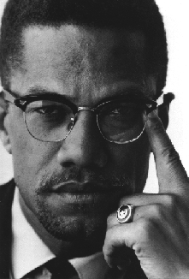

**Nobel Peace Prize**

**The Black Panther movement**

‘

Malcolm X and the Nation of Islam

Reasons for growth of Black Power

**Freedom riders sit-ins and voting rights**

**Non-violent direct action**

**General reasons for growth of protest movements**

**The student movement and link to Vietnam War**

**Betty Friedan, Eleanor Roosevelt, NOW**

**Students for Democratic Society and ‘hippies’**

Protest Movements

**Women’s liberation movement, abortion and Phyllis Schafly**

[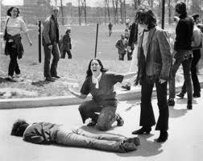](http://www.google.co.uk/imgres?q=1960s+usa+student+protests&hl=en&biw=1280&bih=799&tbm=isch&tbnid=5Q0m1no-p8wfKM:&imgrefurl=http://brainz.org/10-greatest-protests-20th-century/&docid=1EzZo-2ZA43i-M&imgurl=http://media.brainz.org/uploads/2011/03/07_-_vietnam_war_protests_1.jpg&w=600&h=476&ei=xyqhT471M66Q4gTUwuCFCQ&zoom=1&iact=hc&vpx=841&vpy=77&dur=281&hovh=200&hovw=252&tx=147&ty=126&sig=106023214592532908345&page=1&tbnh=129&tbnw=164&start=0&ndsp=24&ved=1t:429,r:4,s:0,i:75)

[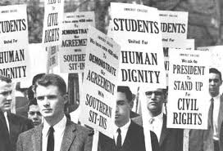](http://www.google.co.uk/imgres?q=1960s+usa+student+protests&hl=en&biw=1280&bih=799&tbm=isch&tbnid=HGzkEwdSbFOSfM:&imgrefurl=http://www.gcsehistory.org.uk/modernworld/usa_civilrights/studentprotests.htm&docid=HDZRmqC46TcFIM&imgurl=http://www.gcsehistory.org.uk/modernworld/usa_civilrights/images/studentprotests1960.jpg&w=350&h=238&ei=xyqhT471M66Q4gTUwuCFCQ&zoom=1&iact=hc&vpx=174&vpy=84&dur=3276&hovh=185&hovw=272&tx=167&ty=126&sig=106023214592532908345&page=1&tbnh=129&tbnw=184&start=0&ndsp=24&ved=1t:429,r:0,s:0,i:67)

**CREEP**

**The Break in**

**The cover up**

Nixon and Watergate

[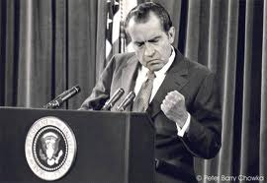](http://www.google.co.uk/imgres?q=Nixon&hl=en&biw=1280&bih=799&tbm=isch&tbnid=o5g0B00pRdaeYM:&imgrefurl=http://jbm479.wordpress.com/2009/08/09/history-president-nixon-resigns-1974/&docid=NoYU8FSg_1uIjM&imgurl=http://jbm479.files.wordpress.com/2009/08/01nixon-web-c.jpg&w=800&h=552&ei=9CuhT72DPYj54QTpipXrCA&zoom=1&iact=hc&vpx=596&vpy=187&dur=1030&hovh=186&hovw=270&tx=162&ty=114&sig=106023214592532908345&page=1&tbnh=133&tbnw=177&start=0&ndsp=27&ved=1t:429,r:3,s:0,i:127)

**The Watergate tapes**

**Laws to reduce politicians’ influence**