**How did Hitler become Chancellor in January 1933?**

Complete the table by using pages 70-71 of the textbook. Try to explain the causes and significance (importance) of each event:

|  |  |  |  |  |
| --- | --- | --- | --- | --- |
| Date | Elections and government | Chancellor | Causes | Significance |
| **1932** | | | | |
| **March and April** | Hitler stood for president and lost. | Bruning |  |  |
| **May** | Nazis asked to join government coalition. | Von Papen |  |  |
| **July** | **Reichstag Election:** Nazis now biggest party (230 seats). | Von Papen |  |  |
| **November** | **Reichstag Election:** Nazis still biggest party (190 seats) | Von Papen |  |  |
| **December** | New Chancellor | Von Schleicher |  |  |
| **1933** | | | | |
| **January** | New Chancellor | Hitler |  |  |

[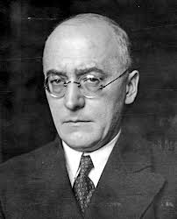](http://www.google.com.hk/url?sa=i&rct=j&q=&esrc=s&frm=1&source=images&cd=&cad=rja&docid=APQA1hkgX7pHuM&tbnid=zO-GjSGJlxz99M:&ved=0CAUQjRw&url=http%3A%2F%2Fgiannellachannel.info%2F2013%2F03%2F19%2Fhelmut-schmidt-europa-che-sogno-europa-che-vedo%2F&ei=UfV9UbKaLeyZiQffyIGYCA&psig=AFQjCNEbjOQtr1o1gJCvzZIe9XBdWvzpQA&ust=1367295681021601)[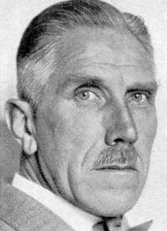](http://www.google.com.hk/url?sa=i&rct=j&q=&esrc=s&frm=1&source=images&cd=&cad=rja&docid=wTwgfYESDlJvAM&tbnid=fWGWfKqn1QuVsM:&ved=0CAUQjRw&url=http%3A%2F%2Fwww.dhm.de%2Flemo%2Fhtml%2Fbiografien%2FPapenFranz%2F&ei=JfV9UZqLGo3uiAe3yIDIDQ&psig=AFQjCNHM7wt7KCa-je-iGdOhGQzSPyqdYg&ust=1367295600334748)[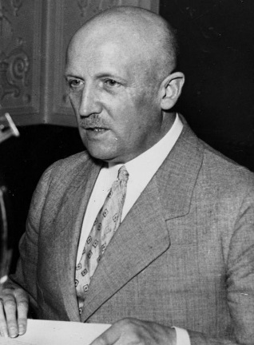](http://www.google.com.hk/url?sa=i&rct=j&q=&esrc=s&frm=1&source=images&cd=&cad=rja&docid=EJQlOJ5EuCgSwM&tbnid=25mxy0v1O2MbxM:&ved=0CAUQjRw&url=http%3A%2F%2Fcommons.wikimedia.org%2Fwiki%2FFile%3ABundesarchiv_Bild_183-B0527-0001-020%2C_Kurt_von_Schleicher.jpg&ei=m_F9UaMf5oqJB8vugZAF&psig=AFQjCNEbQ3Y8Jxq_f1RDja3rDcDgv9DgVA&ust=1367294712697025)

**Franz von Papen, Chancellor May-Nov 1932**

**Heinrich Bruning, Chancellor 1930-1932**

**Kurt von Schleicher, Chancellor Dec-Jan 1933**