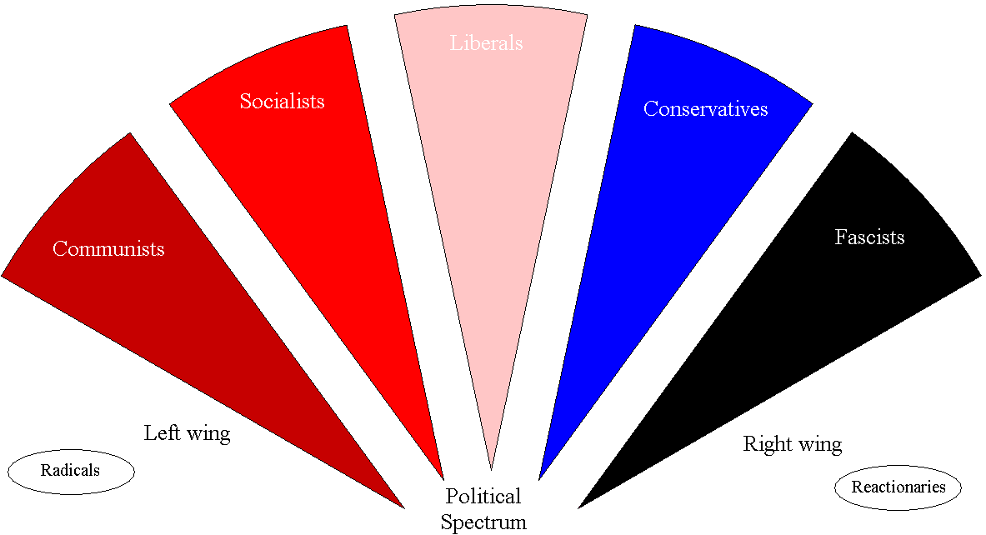

**Reactionaries:** Reactionaries want to go back to 'better times'.

 *Left* vs. *Right* Political Spectrum

**Left Wing**

**Right Wing**

**Conservative**

**Fascist**

**Liberal**

**Socialist**

**Communist**

**Radicals:** Radicals believe that great social change is a good thing.

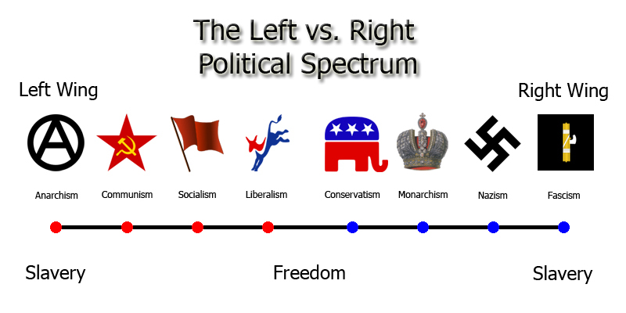

|  |  |  |  |  |
| --- | --- | --- | --- | --- |
| Communism  Communists believe that the state should own and control everything so that everyone can be equal. Political opposition is not allowed. | Socialism  Socialists believe that rights are more important than freedom, but won't take freedom away. | Liberalism  Liberals believe that governments should have a balance between rights and freedom. | Conservativism  Conservatives believe that freedom is more important than rights. They think that the government should not have too much control over people's lives. | Fascism  Fascists believe in the importance of having a powerful dictator and state control. Political opposition is not allowed. |