Why did the Nazis commit mass murder?

Types of individuals | Asocials or Biological Outsiders
Habitual criminals
Work-shy
Jews
Alcoholics
Homosexuals
Juvenile delinquents
Gypsies
Tramps and beggars
Prostitutes
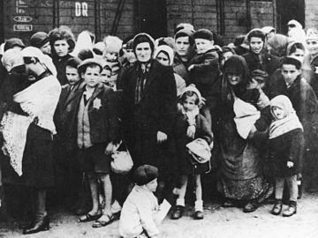
Make brief notes on what caused the Holocaust.
What is Euthanasia?
Who was Dr Josef Mengele and what did he do?
How did the Nazis treat the asocials?
Identity between the asocials and biological outsiders.

How did the Nazis treat the Jews?
FACT

What was Reichskristallnacht (Night of the Broken Glass).
People sent to concentration camps | What was used to identify them
Political prisoners (socialists, communists) | Red triangle
Homosexuals | Pink triangle
Certain religious people | Purple triangle
Asocials | Black triangle
Jews | Yellow star
(Above) Source 1 - A disputation brought up by Israeli historian and scholar Yehuda Bauer.
Prisoners in Nazi concentration camps were made to wear badges to identify them. These were sewed on jackets and shirts and were seen as badges of shame.
"The basic motivation [of the Holocaust] was purely ideological, rooted in an illusionary world of Nazi imagination, where an international Jewish conspiracy to control the world was opposed to a parallel Aryan quest. No genocide to date had been based so completely on myths, on hallucinations, on abstract, nonpragmatic ideology—which was then executed by very rational, pragmatic means."

To what extent to you agree with source 1, and why?

